Introduction
In the past you turned an LED on and off to make it flash. You found then that if the rate at which you turn the LED on and off is too high then your eye can no longer follow the variation in intensity and you see the LED showing a steady light that is dimmer than the LED turned on normally. Now, if you were to alter the fraction of time that the LED is turned on you would alter the brightness of the LED.
You would then be driving the LED with a Pulse Width Modulated signal, as shown in the picture below.
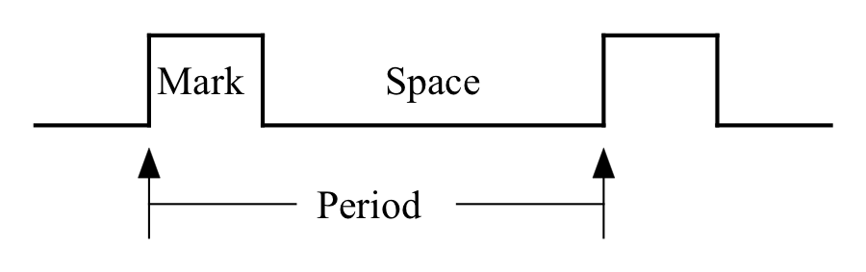
The greater the fraction of time the signal is high (Mark) the brighter the LED will be. We often talk about varying the Mark/Space ratio, which is not quite what it sounds like. The Mark/Space ratio is actually the ratio Mark/(Mark + Space) = Mark/Period. As it varies from 0→1 the LED brightness varies from off to fully on.

1) LED Dimmer the hard way
a) You are going to vary the brightness of the LED connected to pin D13 of your Feather computer. Start with the program from the end of Lab 1 that allows you to control the LED with single letter commands.
If you didn't do that one then start from the last program in Lab 18 but modify it to work with CircuitPython's regular input() function instead of the UART and then verify that it still works.

b) Next modify the program so that, when a key is not pressed, it blinks the LED at a rate that is too fast for you to see the blinking. Since the goal is to have a constant flash rate but a variable on-time I suggest that you think about how you might use the following lines of code in your program.
OnTime = 0.01 # Should be a global
time.sleep(OnTime)
time.sleep(0.03-OnTime)
Once you have the LED blinking too fast to see, add the ability to vary the Mark/Space ratio by pressing single key commands and demonstrate to me that you can vary the brightness of your LED.
Describe how you control the mark-space ratio.

Save your commented program and paste a copy below.

2) LED Dimmer the easy way
Generating pulse-width modulated pulses like this is expensive to do in software and so many processors, our SAMD51 included, provide hardware support that allows us to designate a pin as a PWM source with a given frequency and then the hardware will generate the pulses and allow us to alter the mark-space ratio any time we want. CircuitPython gives us access to these hardware abilities through the pulseio library that we can access in the usual way
import pulseio
The functions in this module are described in Chapter 8 of the computer text and also in the online CircuitPython documentation.
Note that our computer does not support PWM on all pins, only on A2-A5, D4-D6, D9-D13, RX, TX, SCL, and SDA. If you ask for PWM on a pin that does not support it CircuitPython will stop and print an error message.
For example, to set pin D4 to generate 1 ms period PWM (that is 1 kHz frequency) with a starting mark-space ratio, also called the duty_cycle, of 50:50, you could use the following line
pwm_pin = pulseio.PWMOut(board.D4, duty_cycle=32767, frequency=1000)
Then you could turn the duty cycle all the way up with a call
pwm_pin.duty_cycle = 65535
Note that the duty_cycle is, for some historic reason, a 16-bit integer in the range 0-65535. You might find it convenient to do something like
MAX_DUTY = 65535
pwm_pin.duty_cycle = 0.3 * MAX_DUTY
to set the duty cycle to 30% on.
a) Replace your software PWM with calls to the PWM library and demonstrate that you can still control the brightness of your LED.

b) Look at the signal on D13 with your oscilloscope, paset an image in the frame below, and explain what you see.

c) Describe and explain what happens as you vary the brightness.

Again, comment the program and paste it below.

3) Motor Speed Controller
You have just acquired a robot that has pair of very special electric motors driving its two wheels. These are called continuous rotation servo-motors. They have three wires coming out of them; red, black, and white. The red wire needs to go to +5V and the black wire to ground. The white wire needs to be fed from a special pulse width modulated signal. This signal needs to be high for 1.3->1.7 mS then low for a total of about 20 mS.
a) Start by copying the code from your LED dimmer and modify it to send a pulse-width modulated signal to pin D4 following the timing rules above. Verify the timing using your scope and paste a picture of the output below.

Now connect your motor to +5V & ground from your Digi-Designer and to pin D4 on your Feather and explore the relationship between duty_cycle and motor rotation.
Start with a 1.5 ms on-time and, if your motor does not stop, talk to me about adjusting your motor. Once your motor stops when sent a 1.5 ms mark then you can fill in the rest of the table.
Mark time | Motor behaviour
1.30 ms
1.35 ms
1.40 ms
1.45 ms
1.50 ms
1.55 ms
1.60 ms
1.65 ms
1.70 ms
Again, paste your commented code below.

This will become useful next week when we start to send the robots off on their own.

4) Sing a little song
So far you have altered the duty cycle of the PWM signal but not played with the frequency. While it is less usual, it is possible to alter the PWM frequency on the fly as well. In order to do this, however, you have to have requested the ability when you set up the PWMOut by passing in an extra keyword argument. Here is the form to request a variable frequency pin
pwm_pin = pulseio.PWMOut(board.D4, duty_cycle=32767, frequency=1000, variable_frequency=True)
Once a pin has been initialized in this way, you can change the frequency simply by assigning to the frequency property, like this
pwm_pin.frequency = 250
a) Modify your program to support varying the frequency an hook your oscilloscope up to pin D4. Experiment with different frequencies and find the range of frequencies that the Feather can support.

b) While the Feather does not supply enough current to drive a regular loudspeaker, there is enough signal to drive a small piezo-electric speaker so I have provided one. Connect the piezo speaker between pin D4 and ground and verify that you can play a tone through it.

c) The notes of a simple C major scale have the frequencies C 262 Hz, D 294 Hz, E 330 Hz, F 350 Hz, G 392 Hz, 440 Hz, B 494 Hz. Higher and lower octaves can be obtained by multiplying or dividing these frequencies by 2.
Write a program to play a tune on your piezo-electric speaker.
If you are interested you might also want to experiment with altering the duty-cycle away from 50% to alter the tone quality of the sound.
Demonstrate your tune to me and paste your commented program below.

